ST. XAVIER’S COLLEGE

**Maitighar, Kathmandu**



**Computer Graphics**

**Lab Assignment #4**

**SUBMITTED BY:**

**Siddhant Rimal**

**013BSCCSIT039**

**SUBMITTED TO**

|  |  |
| --- | --- |
| **Er. Anil Sah**  **( Lecturer )** |  |
| **Department of Computer Science** | |

Submission Date: August 18th 2015

**OBJECTIVE 4.1: TO PLOT A LINE WITH BLA ALGORITHM**

|  |  |
| --- | --- |
| **Algorithm:** | |
| Step 1 | Start |
| Step 2 | Input the two line endpoint and store the left endpoint at (xo , yo ) |
| Step 3 | Load (xo , yo ) in to frame buffer, i.e. Plot the first point. |
| Step 4 | Calculate constants 2dx,2dy calculating dx,dy and obtain first decision  parameter value as po = 2dy - dx |
| Step 5 | At each  xk along the line, starting at k=0, perform the following test, |
| Step 6 | if pk = 0,next point is (xk +1, yk )  pk+1 = pk + 2dy otherwise,  next point to plot is (xk +1, yk +1)  pk+1 = pk + 2dy - 2dx |
|  |  |
| Step 7 | Repeat step 6 dx times. |
| Step 8 | Stop |

|  |
| --- |
| **Source Code:** |
| //--------------------------------------------------------------------------- |
| #include <vcl\vcl.h> |
| #pragma hdrstop |
|  |
| #include "bla.h" |
| //--------------------------------------------------------------------------- |
| #pragma resource "*.dfm" |
| TForm1 *Form1; |
| int X,Y; |
| int dx,dy,pk,x1,y1,x2,y2,n,nc; |
| //--------------------------------------------------------------------------- |
| __fastcall TForm1::TForm1(TComponent* Owner) |
|  |
| { |
| } |
| //--------------------------------------------------------------------------- |
| void __fastcall TForm1::Button1Click(TObject *Sender) |
| { |
| x1=StrToInt(X1->Text); |
| x2=StrToInt(X2->Text); |
| y1=StrToInt(Y1->Text); |
| y2=StrToInt(Y2->Text); |
| dy=y2-y1; |
| dx=x2-x1; |
| n=dx; |
| Y=y1; |
| X=x1; |
| pk=2*dy-dx; |
| do{ |
| Image1->Canvas->Pixels[X][Y]=RGB(0,0,255); |
| if (pk<0) |
| { |
| X=X+1; |
| pk=pk+2*dy; |
| } |
| else |
| { |
| X=X+1; |
| Y=Y+1; |
| pk=pk+2*dy-2*dx; |
| } |
| nc++; |
| }while(nc<n); |
|  |
| } |
| //--------------------------------------------------------------------------- |

**OUTPUT:**

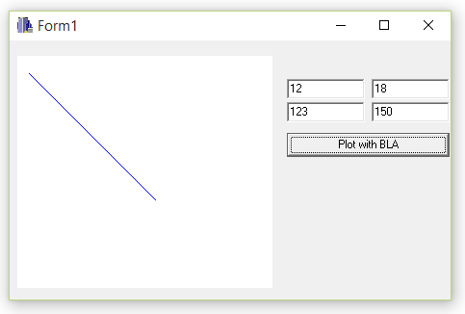

Fig: Plotting Line with BLA Algorithm

**CONCLUSION:**

The program could plot a simple line following the BLA algorithm. The program needs X1,Y1, X2 and Y2 co-ordinate values to operate.